**EXPERIMENT: 2**

**DATE:**

**DATA MANIPULATIONS**

**Create the following tables with the given structure.**

**EMPLOYEES TABLE**

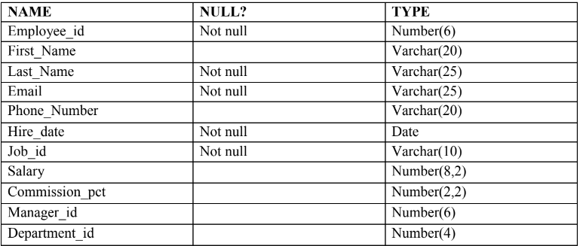

create table EMPLOYEE(Employee_id Number(6) Not null,First_Name Varchar(20),Last_Name Varchar(25) Not null,Email Varchar(25)  Not null,Phone_Number Varchar(20),Hire_date Date Not null,Job_id Varchar(10) not null, Salary Number(8,2),Commission_pct Number(2,2),Manager_id Number(6),Department_id Number(4));

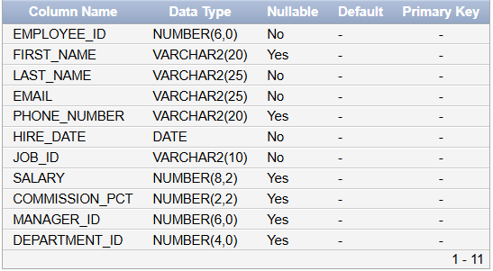

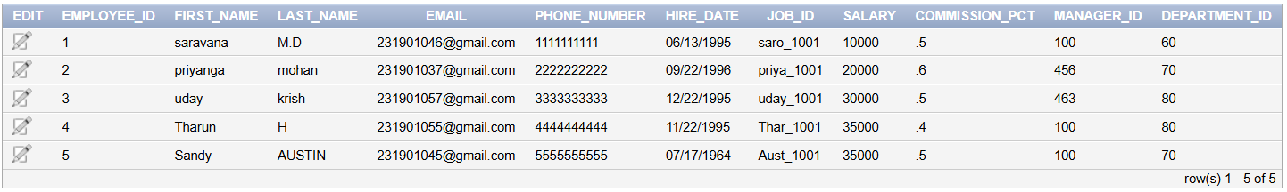

**INSERT INTO employees (employee_id, first_name, last_name, email, phone_number, hire_date, job_id, salary, commission_pct, manager_id, department_id)**

**VALUES (1, 'saravana', 'M.D', '231901046@gmail.com', '1111111111', TO_DATE('1995-06-13', 'YYYY-MM-DD'), 'saro_1001', 10000, 0.5, 100, 60);**

**INSERT INTO employees (employee_id, first_name, last_name, email, phone_number, hire_date, job_id, salary, commission_pct, manager_id, department_id)**

**VALUES (2, 'priyanga', 'mohan', '231901037@gmail.com', '2222222222', TO_DATE('1996-09-22', 'YYYY-MM-DD'), 'priya_1001', 20000, 0.6, 456, 70);**

**INSERT INTO employees (employee_id, first_name, last_name, email, phone_number, hire_date, job_id, salary, commission_pct, manager_id, department_id)**

**VALUES (3, 'uday', 'krish', '231901057@gmail.com', '3333333333', TO_DATE('1995-12-22', 'YYYY-MM-DD'), 'uday_1001', 30000, 0.5, 463, 80);**

**INSERT INTO employees (employee_id, first_name, last_name, email, phone_number, hire_date, job_id, salary, commission_pct, manager_id, department_id)**

**VALUES (4, 'Tharun', 'H', '231901055@gmail.com', '4444444444', TO_DATE('1995-11-22', 'YYYY-MM-DD'), 'Thar_1001', 35000, 0.4, 100, 80);**

**INSERT INTO employees (employee_id, first_name, last_name, email, phone_number, hire_date, job_id, salary, commission_pct, manager_id, department_id)**

**VALUES (5, 'Sandy', 'AUSTIN', '231901045@gmail.com', '5555555555', TO_DATE('1964-07-17', 'YYYY-MM-DD'), 'Aust_1001', 35000, 0.5, 100, 70);**

1. **Find out the employee id, names, salaries of all the employees**

SELECT  
    employee_id,  
    first_name,  
    last_name,  
    salary  
FROM  
    employee;

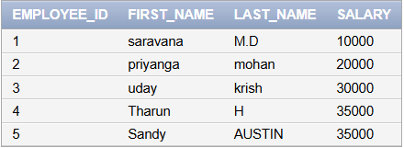

1. **List out the employees who works under manager 100**

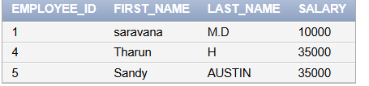

**SELECT**

**employee_id,**

**first_name,**

**last_name,**

**salary**

**FROM**

**employee**

**WHERE**

**manager_id = 100;**

**(c) Find the names of the employees who have a salary greater than or equal to 4800**

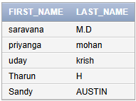

**SELECT**

**first_name,**

**last_name**

**FROM**

**employee**

**WHERE**

**salary >= 4800;**

**(d) List out the employees whose last name is ̳AUSTIN‘**



**SELECT**

**employee_id,**

**first_name,**

**last_name,**

**salary**

**FROM**

**employee**

**WHERE**

**last_name = 'AUSTIN';**

**(e) Find the names of the employees who works in departments 60,70 and 80**

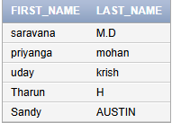

**SELECT**

**first_name,**

**last_name**

**FROM**

**employee**

**WHERE**

**department_id IN (60, 70, 80);**

**(f ) Display the unique Manager_Id.**

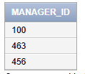

**SELECT DISTINCT**

**manager_id**

**FROM**

**employees;**

**Create an Emp table with the following fields: (EmpNo, EmpName, Job,Basic, DA, HRA,PF,**

**GrossPay, NetPay) (Calculate DA as 30% of Basic and HRA as 40% of Basic)**

CREATE  
TABLE EMP1 (  
    EmpNo INT PRIMARY KEY, EmpName  
VARCHAR(100), Job VARCHAR(50),  
    Basic DECIMAL(10, 2),  
    DA DECIMAL(10, 2),  
    HRA DECIMAL(10, 2),  
    PF DECIMAL(10, 2),  
    GrossPay DECIMAL(10, 2),  
    NetPay DECIMAL(10, 2)  
);  
  
UPDATE  
Emp1  
SET  
    DA = Basic * 0.30,  
    HRA = Basic * 0.40,  
    GrossPay = Basic + DA + HRA,  
    NetPay = GrossPay - PF;

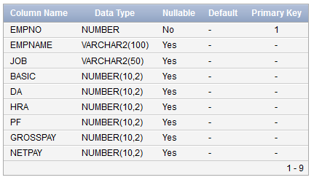

1. **Insert Five Records and calculate GrossPay and NetPay.**

INSERT INTO Emp (EmpNo, EmpName, Job, Basic, PF) VALUES (1, ' vedant', 'Manager', 50000, 2500);

INSERT INTO Emp (EmpNo, EmpName, Job, Basic, PF) VALUES (2, ' Tharun', 'Developer', 40000, 2000);

INSERT INTO Emp (EmpNo, EmpName, Job, Basic, PF) VALUES (3, 'priyanga', 'admin', 35000, 1750);

INSERT INTO Emp (EmpNo, EmpName, Job, Basic, PF) VALUES (4, 'viji', 'director', 45000, 2250);

INSERT INTO Emp (EmpNo, EmpName, Job, Basic, PF) VALUES (5, saravana', 'hacker', 55000, 2750);

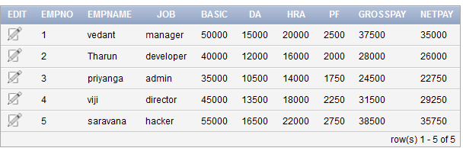

1. **Display the employees whose Basic is lowest in each department.**

SELECT EmpNo, EmpName, Job, Basic, DA, HRA, PF,  
GrossPay, NetPay FROM Emp1 WHERE (Job, Basic) IN (SELECT Job, MIN(Basic) FROM  
Emp1 GROUP BY Job);

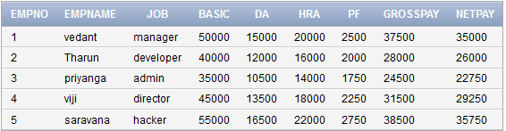

**(c) If Net Pay is less than**

SELECT EmpNo, EmpName,

Job, Basic, DA, HRA, PF, GrossPay, NetPay FROM Emp1 WHERE NetPay < 40000;

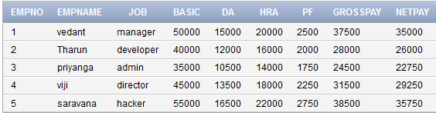

**DEPARTMENT TABLE**

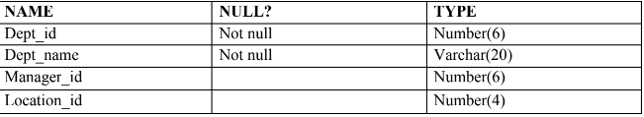

CREATE TABLE Department (

Dept_id NUMBER(6) NOT NULL,

Dept_name VARCHAR2(20) NOT NULL,

Manager_id NUMBER(6),

Location_id NUMBER(4),

PRIMARY KEY (Dept_id)

);

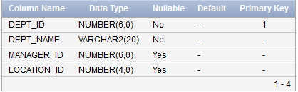

**JOB_GRADE TABLE**

CREATE TABLE JOB_GRADE (

Grade_level VARCHAR2(2),

Lowest_sal NUMBER,

Highest_sal NUMBER

);

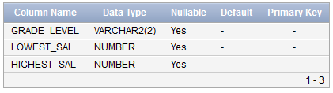

**LOCATION TABLE**

CREATE TABLE LOCATION (

Location_id NUMBER(4) NOT NULL,

St_addr VARCHAR2(40),

Postal_code VARCHAR2(12),

City VARCHAR2(30) NOT NULL,

State_province VARCHAR2(25),

Country_id CHAR(2),

PRIMARY KEY (Location_id)

);

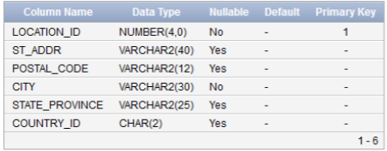

1. Create the DEPT table based on the DEPARTMENT following the table instance chart

below. Confirm that the table is created.

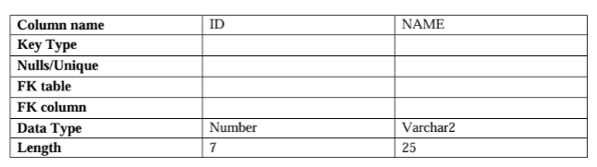

CREATE TABLE DEPT1 (

ID NUMBER(7) NOT NULL,

NAME VARCHAR2(25) NOT NULL,

PRIMARY KEY (ID)

);

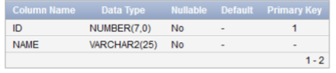

SELECT table_name

FROM user_tables

WHERE table_name = ‘DEPT1’;

2. Create the EMP table based on the following instance chart. Confirm that the table is

created.

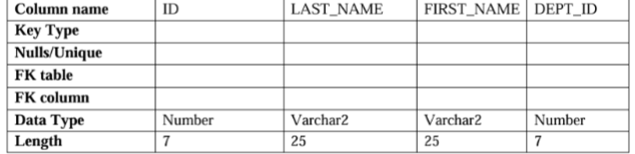

CREATE TABLE EMP2 (

ID NUMBER(7) NOT NULL,

LAST_NAME VARCHAR2(25) NOT NULL,

FIRST_NAME VARCHAR2(25),

DEPT_ID NUMBER(7),

PRIMARY KEY (ID)

);

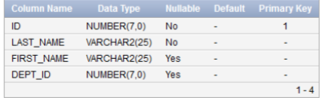

SELECT table_name

FROM user_tables

WHERE table_name = ‘EMP’;

3 Modify the EMP table to allow for longer employee last names. Confirm the

modification.(Hint: Increase the size to 50)

ALTER TABLE EMP2 MODIFY (LAST_NAME VARCHAR2(50));

SELECT column_name, data_type, data_length

FROM user_tab_columns

WHERE table_name = ’EMP2’;

AND column_name = ’LAST_NAME’;



4 Create the EMPLOYEES2 table based on the structure of EMPLOYEES table. Include

Only the Employee_id, First_name, Last_name, Salary and Dept_id coloumns. Name the

columns Id, First_name, Last_name, salary and Dept_id respectively.

CREATE TABLE EMPLOYEES2 (

Id NUMBER(6) PRIMARY KEY, -- Corresponds to Employee_id

First_name VARCHAR2(20), -- Corresponds to First_Name

Last_name VARCHAR2(25) NOT NULL, -- Corresponds to Last_Name

salary NUMBER(8, 2), -- Corresponds to Salary

Dept_id NUMBER(4) -- Corresponds to Department_id

);

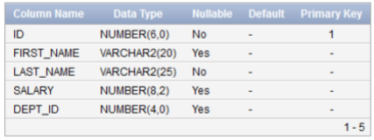

5 Drop the EMP table.

DROP TABLE EMP2;\

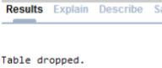

6 Rename the EMPLOYEES2 table as EMP.

ALTER TABLE EMPLOYEES2 RENAME TO EMP2;



7 Add a comment on DEPT and EMP tables. Confirm the modification by describing the

table.

COMMENT ON TABLE DEPT1 IS &#39;Department details&#39;;

COMMENT ON TABLE EMP2 IS &#39;Employee details&#39;;

SELECT table_name, comments

FROM user_tab_comments

WHERE table_name IN (‘DEPT1’,’EMP2’);

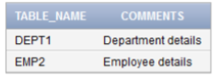

8 Drop the First_name column from the EMP table and confirm it.

ALTER TABLE EMP DROP COLUMN FIRST_NAME;

SELECT column_name

FROM user_tab_columns

WHERE table_name =’EMP2’;

